**Green Society Public School**

**D-06**

**Ratnanagar-7, Sauraha, Chitwan**

**Second Terminal Examination-2082**

**Class: UKG Time: - 2 hrs. F.M.: 50**

**Sub: English**

|  |
| --- |
| **Name: Roll No.: Sec.:** |
| **­­­­­­­­­­­­ ________________ ______________ OBT.MARKS:**  **INVIGILATOR EXAMINER** |

1. **Write down action word. (3)**

1. **Answer the following questions. (3)**
2. **What is your name?**

My name is ……………………………..………………….…

1. **How old are you?**

I am …..………………….… years old.

1. **Make 2/2 words. (4)**

C

F

B

M

1. **Put ‘a’ or ‘an’ before words. (5)**
2. ………….orange d. ………… cat
3. ………….fan e. ………… iron
4. ………….mango
5. **Make 'en' words. (5)**

…………………………… ……………………………….

…………………………... ……………………………….

…………………………...

1. **Change singular into plural. (5)**

**a.** Pen =

b. cat =

c. ball =

d. potato =

e. baby =

1. **Make sentences using ‘These’ and ‘Those’. (5)**
2. 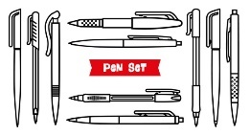……………… are pens.

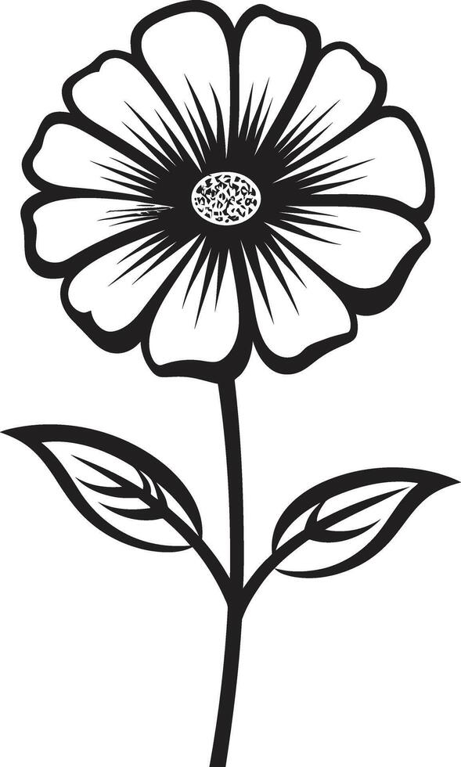

1.  ……………..are flowers.
2. 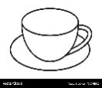 ……….are Butterflies.
3. …………… are cups.
4. **Add ‘ing’. (5)**

Cook=

Play=

Go=

Eat=

Drive=

**9) Fill in the blanks with He/She/ It. (5)**

1. …………… is a boy.
2. …………… is a girl.
3. …………… is a mango.
4. ………….. is a mat.
5. …………. is a mother.

**10) Make sentences with the help of the given table. (6)**

**The End**